Learn about True Parents’ life course and apply it to your life.

Education Department of FFWPU International HQ
Holy Ground Pilgrimage

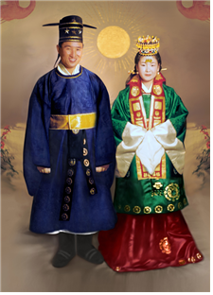
Cheongpa-dong Old Headquarters Church

송거원세지년 (送去怨世之年)
환래행세지년 (歡來幸世之年)
천주지원효진 (天宙之願孝進)
중생지원충진 (衆生之願忠進)

Ring out the years of the sorrowful past
Ring in the years of happiness to come
The wish of the cosmos is for filial piety
The hope of humanity is the advent of loyalty

The Heart of Restoration, The Way of God’s Will
Wearing traditional Korean clothing, True Father
wrote these lines in the small room next to the chapel. He expressed the hope that we would all do our duty as loyal sons and daughters and go the way of the Will.

Toward a New Era of Happiness

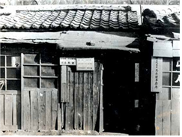
On May 1, 1954, the Holy Spirit Association for the Unification of World Christianity was established in a small house True Father had moved to, called Sedaemoon House, at 391-6 Ilmyeong, Bukhak-dong Seongdong-gu, Seoul. On January 17, 1955, due to a sudden storm of witnessing that brought many people, the headquarters church moved to 241-44 Hongin-dong, Seongdong-gu, and then again to 1-37 Jangchung-dong Jung-gu in Seoul a few months later, on April 27.
Students and professors from Christian mission schools, including the prestigious Ehwa Women’s University and Yonsei University, had begun to convert to the Unification Church. When the Ehwa Christian Student Council took an interest in the new teaching, the Christian schools grew alarmed and began to persecute the Unification Church. Yonsei University fired Professor Sang-rae Park in March, 1955, and expelled two students, Hwan-chae Hwang and Gyeong-gyu Yu, four months later, on July 7. Ehwa University fired five professors – Yun-yeong Yang, Chung-hwa Han, Won-bok Choi, Yeong-un Kim and Jeong-ho Lee – and expelled fourteen students – Mi-shik Shin, Gil-ja Sa, Jeong-eun Kim, Myeong-jin Seo, Gyeong-shik Kim, Seung-gyu Park, Seng-ryeon Ji, Dae-hwa Jeong, Yeong-suk Park, Seung-he Im, Gye-sun Lee, Jeong-won Gang, Sun-hwa Choi and Suk-ja Kim. Starting from these Christian figures, criticism and persecution of the Unification Church began to rage.
As society increasingly condemned the Unification Church as a cult, True Father was taken into custody on July 4, 1955, by the Special Intelligence Division of the Police and detained at the Central Police Station. He was charged with evading military service. From there he was sent to Seodaemun Prison, where he spent three months before he was found not guilty and discharged.
As True Father was released from Seodaemun Prison on October 4, 1955, he pledged that he would conduct a movement for peace based on the Unification Church. With a deposit of 2 million won (less than US$2,000) from the Jangchung-dong Church, the church bought a two-story wooden house that had belonged to the former enemy, the Japanese, at 71-3, 1-Ga Cheongpa-dong Yongsan-gu. Just three days after Father’s release from prison, the Unification Church headquarters was set up as a place that could be claimed by God, a place where God could settle. True Father said that Yongsan (용산, 龍山: the highest mountain), and Cheongpa (청파, 靑坡: green hill, the ideal), meant the ultimate ideal world, and that Cheongpa-dong, Yongsan-gu would become a place where people would hope and sing for this kind of world.
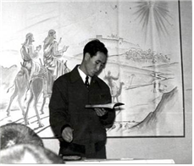
On the day Father moved into this headquarters building to begin the full-scale launch of the Unification Movement, members gathered and held a Ceremony to Welcome True Father from Prison and Open the Headquarters Church. True Father personally passed out popped rice and apples to each member, and encouraged them. It was such a happy assembly with True Father. The members clapped so hard their hands bled, and cried so hard their faces ran with tears and their noses dripped.
On the first floor of the two-story tiled-roof house, workshops and worship services took place. New members came day and night to spend time with True Father, filled with the spirit of grace and truth in his words. True Father said, “Every pillar, every piece of tile, even every window must be kept exactly as it is.”
On Sundays, when members would be packed into the church, True Father would respond by speaking passionately for three or four hours. When leadership workshops were held, members would curl up and sleep in the chapel. After Sunday service they would have to prepare lunch, but finding enough food, clothing, and shelter was never easy for Unification Church members. Due to poor cooking facilities, they often cooked corn porridge outside. No one could have more than one bowl because there were so many people. However, even in this situation the praise and prayer continued through the night, and spiritual phenomena often occurred. There were revelations, visions and vibrations, and when someone could not control it, True Father would help.
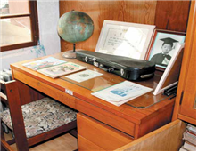
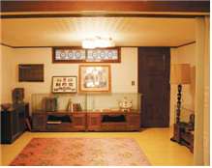
On the inner part of the first floor is the room that True Parents used to use. The one behind the chapel is where True Mother stayed. It had not even been a bedroom, but they remodeled it so it could be used as one. True Mother lived in this room and gave birth to True Children there. Exactly above on the next floor were True Father’s rooms. True Mother and True Father used these small, dark, windowless rooms, and offered their prayer and sincere devotion there.
True Father’s office was located on the inner part of the second floor, in a very tiny space. On his desk there were two small models. One was a turtle boat representing Korea, and the other a golden pavilion representing Japan. True Father offered such sincere devotion and shed so many tears that the story of how his tears soaked through to the first floor is still told. He slept barely two or three hours each day, and led the providence within a rigorous schedule.
True Parents’ Engagement Ceremony took place at this church on March 27, 1960 (lunar 3/16), and their Holy Wedding Ceremony on April 11, 1961 (lunar 5/15). Also, the Blessing ceremonies of the first three couples (April 16), 33 couples (May 15, 1961), and 72 couples (June 4, 1962) took place there, as well as the engagement ceremonies of the 124 couples, 777 couples and 1800 couples.

The True Children who were born here are Ye-jin Nim (lunar 12/11, 1960), Hyo-jin Nim (lunar 12/3, 1962), Hye-jin Nim (lunar 6/20, 1964), In-jin Nim (lunar 7/18, 1965), Heung-jin Nim (lunar 10/23, 1966), and Eun-jin Nim (lunar 11/23, 1967).
Holy Days such as True Parents’ Day (lunar 3/1, 1960), True Children’s Day (lunar 10/1, 1960), True Day of All Things (on lunar 6/6, 1963, the lunar date 5/1 was decided as the Day of All Things), and True God’s Day (Jan. 1, 1968) were proclaimed in this church. Also many workshops, including 16 of the first 17 40-day workshops (excluding the second), as well as 21-day and 14-day workshops, were held here, until 1969.
Starting with his world tour to 40 countries that began on January 28, 1965, True Father chose 120 holy grounds. The first one was the Meiji Shrine in Japan (Jan. 31, 1965), and the last one was the Cheongpa-dong Headquarters Church here in Korea (Jan. 1, 1969). The Headquarters Church, as the central church, was chosen as the Parent Holy Ground to connect all the holy grounds of the 40 countries.

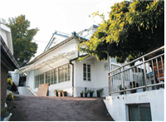
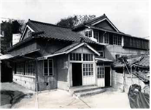
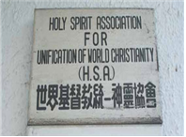

2. Mt. Dobong Holy Ground

The Gwang-ryun Temple where True Parents stayed

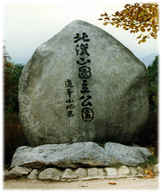
About 300 to 400 meters (around 1000 to 1300 feet) past the entrance and ticket office at Mt. Dobong is the Gwang-ryun Temple (광륜사, formerly called Geumdeuk Temple, 금득사). Thirty years ago there were no houses in this area, and where the Gwang-ryun Temple is now, there was just one tile-roofed house. This house was quite well made, with two rooms and a kitchen. This is the place where True Mother prayed and recovered from the loss of her baby daughter Hyejin Nim (lunar 6/27, 1964) who passed away only eight days after her birth. On January 28, 1965, True Father visited this place before starting his first world tour. True Mother stayed here for about eight months, until October 10, when True Father returned to Korea.
(Reference: History Compilation Committee, Oct. 29, 1996)
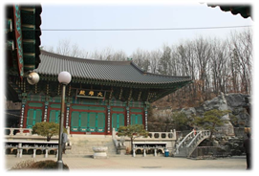
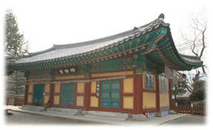

While she was there, True Mother would often walk up and down the mountain to the grave about fifteen minutes away, praying for her lost child. Also, Daemonim, Mu-gyeong Lee, Gil-jae Im, and U-uk Shim would often visit True Mother there.

When you enter the Gwang-ryun Temple grounds, right in front is the main temple, and on the left is a shop selling Buddhist articles. If you look to the right you will see a lone building. This is the building where True Mother stayed.
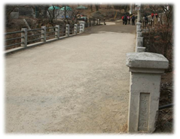
To the left of the ticket office is a bridge with the name Tongilgyo (Unification Bridge), built in 1970. The word Tongilgyo is reminiscent of the “Unity Ceremony.” When True Parents arrived at the hospital in New York around 6:40 a.m. on December 31, 1983, and heard that Heung-jin Nim, their second son, would not survive after being badly injured in an unfortunate traffic accident, they did not go into Heung-jin Nim’s room. Instead they prepared the doctor’s meeting room as a prayer room and held a “Unity Ceremony.” In other words, in the same way that Abraham sacrificed Isaac, and God sacrificed Jesus, True Parents offered Heung-jin Nim as a sacrifice in front of Heaven, and held a ceremony for unity between top and bottom, right and left, and for the change of sovereignty.
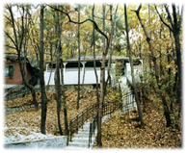
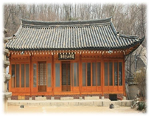
If you walk about 300 meters (1000 feet) from the Unification Bridge you can see Mt. Dobong, and at its foot is a temple called Neungwon Temple (능원사). If you go through the Neungwon Temple grounds, between and around the temples and down the mountain, you will find two small houses that do not look like temple homes, only about four to five pyeong (140 to180 sq ft) in size. The building on the right has a sign with the words Myeong bujeon (명부전). This is the place where Hye-jin Nim is enshrined. Before it was just a plot of farmland, but because the Unification Church had no appropriate land to use as a grave, President Jae-seok Lee’s wife, Mrs. Jeon-won Gang, let them use her own relative’s family burial ground. However, because they kept this gravesite secret from the owner, difficulties arose when it was discovered. Later, when the owner knew the story, the church members asked for understanding and everything was straightened out. Under this kind of situation, the location was not made known and only a few members could visit it.
The words Myeong bujeon are made up of the Korean Chinese characters of myeong (冥, dark, meaning the other world), bu (府, a warehouse, meaning a mausoleum), and jeon (殿, a large house). All together the meaning is “the large house that attends the ones whose fate took them to the other world.” This is the place where the Buddhist monks of the Neungwon Temple pray in front of commemorative tablets for the dead. Neungwon Temple was built in December, 1978, and the Korean Chinese characters are neung (能, able, meaning a star), won (園, hill, meaning a royal grave), sa (寺, temple). Together it means “a temple that attends the star-like prince.”
Ten days after Hye-jin Nim passed away, on August 14, 1964 (lunar 7/7) at 7 a.m., True Father held a “Striking the Spiritual Satan Ceremony” centered on True Parents at the headquarters church. This set the condition for God to forgive Cain and offer Abel as a sacrifice through the passing of the child of the True Family, and to strike Satan. Subsequently, they set the condition to strike Satan spiritually and physically based on Hye-jin Nim’s passing by holding a “Striking the Physical Satan Ceremony” on August 21 (lunar 7/14), 1964, at 11 a.m. at the headquarters church. This was the 40-year course that True Parents had to walk as the course of indemnity for four thousand years of history, and it was the starting point for the course of True Father’s first world tour. Later, True Father said that until 1960 he walked the most wretched path on the family level. He also said that June 7 was the midway point for overcoming the peak of the seven-year course, and that Hye-jin Nim’s death and the death of elderly blessed members were all part of a bigger plan. In addition, he reflected that Korea’s participation in the Vietnam War began four days after Hye-jin NIm’s passing.
At Hye-jin Nim’s grave True Parents shared a poignant experience. Although her grave was moved to Pajuwonjeon on April 7, 1970, monks continue to offer devotions and prayers in the Myeong bujeon, and a new temple has been built on the purified spot where the child of heaven was buried.
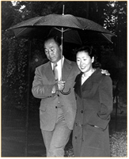
If you come out of the Neungwon Temple, up the same road and around to the hill at the back, there is a road where True Father took True Mother on walks, to help her regain her health and her mental strength. That road has been widened all the way to Dobong Temple, but back then it was just a small narrow trail. It is a trail engraved with the whispers of a couple’s true love. For eight months this trail served as a place for True Mother to recover through her walks, and find comfort after the pain of losing her child. If you go on past Dobong Temple there is a mountain creek and a rock where even now couples like to sit together.

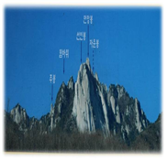
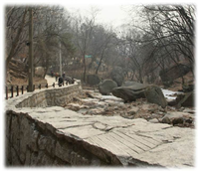

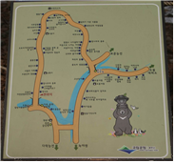

3. Seodaemun Prison

The History of Seodaemun Prison

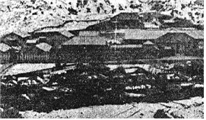
The Japanese Empire had already made Korea its “protectorate” by 1907, and was encountering resistance from many patriotic Koreans. The Japanese were arresting these dissidents and, in order to imprison them, built a large prison near the Independence Gate (독립문, Doklipmun) which represented the independent Korean Empire. The Gyeongseon Prison was designed by the Japanese and cost about 50,000won (US$50) in the currency of that time. It was made up of 145 square meters (1500 square feet) of cells, and about 24 square meters (250 square feet) of other facilities, and could hold 500 people. Only eight prisons nationwide could hold over 300 people. It opened in 1908.
Now the prison is a museum. Its twelve buildings are preserved just as they were. The central building contains an exhibit with information about patriots who died there. Several jail cells now hold exhibits and demonstrations so visitors can experience the environment where torture, trials and imprisonment took place. There is even a wooden execution building which was built in 1923. Next to the execution ground is a secret passageway dug by the Japanese so they could sneak out the bodies of executed prisoners. The women’s underground prison is where patriots such as Gwan-sun Yu (1904-1920) and others were held, known as Gwan-sun Yu’s cave. It is made up of separate rooms smaller than 1 pyeong (36 square feet) and only 1.5m (5 feet) high, so that prisoners could not even stand up straight.

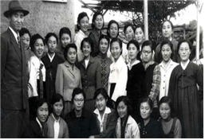
The Full Story of the July 4th Incident

Seodaemun prison is where the Korean government imprisoned True Father under suspicion of evading military service. In reality it was in response to the accusations and persecution from the Christian Church. True Father was arrested on July 4, 1955, at Jangchung-dong church, which was the headquarters church at the time. This was followed by the arrests of Won-pil Kim on July 5, Hyo-min Yu and Hyo-yeong Yu on July 6, and President Hyo-won Yu on July 13. This was a response to the witnessing activities of the Unification Church, which had spread like wildfire at Christian universities including Yonsei and Ehwa Women’s University. The arrests were made at the behest of Christian leaders who appealed to the authorities.
True Father’s case was first taken to Chianguk Special Intelligence Division, then forwarded to the Seoul District Public Prosecutors' Office before he was finally moved to Seodaemun Prison as a prisoner on trial (No. 390).
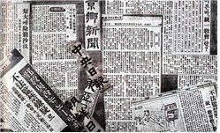
Starting around April of 1955, as students and teachers were kicked out of Yonsei and Ehwa Women’s University, the press began the systematic publication of articles critical of the Unification Church. They accused the Unification Church of being “an obscene and sinful society.” The articles were full of slander, groundless rumors and strange claims, such as, “Unification Church members use electrical equipment to bind you to a chair, they put drugs in the food to brainwash you, dance naked in the basement and have illicit relationships.”
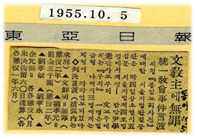
Without the least bit of proof, the police and prosecutors took True Father and other church leaders into custody, accusing them of such crimes as causing social disorder. However, True Father was found innocent and released on October 4.

True Father’s Resolution in Jail

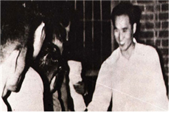
When True Father first entered Seodaemun prison, he was ridiculed by the prison warden and section chief as a world-class villain. However, even in the face of their curses, mockery and ridicule, he handled the situation bravely, merely praying silently. Occasionally, True Father would reprimand the prison officers and point out their falsehoods, according to his spiritual intuition.
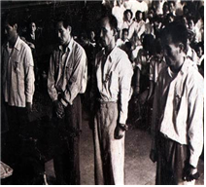
The prison wardens and prisoners alike, seeing True Father constantly praying for the nation, for the people, and for the Will of God, and only sleeping two hours a day, began to respect him before two weeks had passed. Some prisoners received dreams or revelations about True Father. Eventually the prison officers, wardens and section chiefs begged forgiveness of True Father, attended him with respect, and called him teacher. They would bring food such as watermelons, yellow Asian melons, or ice-cream. Even the convicts regarded True Father as a teacher, shared their secrets with him and listened to his words.
True Father said that one day as he was looking out the window of Seodaemun Prison at Gujin Hill, he made a resolution that when he was released he would liberate the convicts that were imprisoned there. He had the heart to console the lost spirits of patriotic martyrs who had died at Seodaemun Prison, and also to relieve the pain and resentment of those he came to know in this place. Later, Gujin Hill was designated a Unification Church holy ground, and is remembered as a place of sincere devotion.
Seodaemun Prison allowed three visitors per day, but until the day True Father was released, 15 visitors would come to the visiting center every day. The guards were impressed by how Unification Church members would line up each day, without fail, to visit True Father. Members received guidance in faith from True Father when they visited, and they shared in his hardships.
Not only that, throughout the time he was in prison, church members relentlessly remained on watch at the main door of the prison, and also at the court and the Public Prosecutor’s Office, offering prayers and devotion for True Father. At the headquarters church, the entire congregation united in offering devotion eight times a day at three-hour intervals starting at midnight.
President Hyo-won Yu, who was briefly imprisoned along with True Father, wrote a poem in the margins of his Bible called “Hardships and New Life” to express his determination. Also, Hwan-chai Hwang, who offered all-night devotion with the young members at the headquarters church, wrote a song called “My Promise,” and even sang it to True Father when he was released.
Hardships and New Life

- Where are His children who answered the call of the archangel sounding afar?
People who trembled as lightning flashed, blasting the sky from the East to the West
Dark is the sun, dim is the moon, thousands of stars falling to darkness;
Where are the ones blessed with new life, liberated from the dead?

2. Now we behold a new heaven and earth, Holy Jerusalem, standing anew;
After our search of six thousand years, Eden rejoices to welcome us home.
All of our tears, wipe them away; sorrowful sighs, we will not need them;
Where is my Lord, He who returns? Where is Heaven's glorious One?

3. Once He departed by way of the cross, now He returns and He suffers again;
One way is given to meet our Lord; follow the path to the bottom of hell.
Glorious star, Lebanon's light, shining on all, lighting the ages;
There is the great city of God, where the sun arises and shines.

4. Come in rejoicing and look to the light, see how the darkness is rolling away;
Out of the few come a multitude; joyfully building the city of God.
Children of life stream through the gates, close to His heart, singing to please Him;
Raising the white cross to the sky, praising our eternal new life.

My Promise

1. I pledge I will go, I pledge I will go; Go as my Father has gone.
Tears fall on the path, lonely and silent the path of the Father
Going to suffer the way of the cross.
Ready to follow His will, I pledge I will go forward to Him.
Ready to follow His will, I pledge I will go forward to Him.

2. I'll follow the way, I'll follow the way; follow the path of my Lord.
Though thorny the path, now persevere as the brightness is growing,
On to the victory and glorious crown;
Giving my body and soul, I'll follow the Lord all of the way;
Giving my body and soul, I'll follow the Lord all of the way.

3. I'm ready to serve, I'm ready to serve, serving my Father's desire.
Trials darken the path, deep in my heart the desire of the ages,
Fighting until we come home to the Lord.
Satan will bow in defeat; I'm ready to serve all of my life;
Satan will bow in defeat; I'm ready to serve all of my life.

4. Heuksok Dong

The traces of True Father’s life of faith, which was closer to God and felt more deeply than anyone in all of history, still remain in this place from his school days.
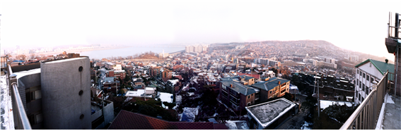

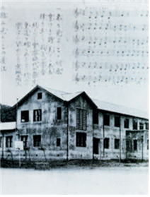
On April 12, 1938, True Father entered the Department of Engineering at Kyongsong Institute of Commerce and Industry, which was formerly a middle and high school affiliated with Chung-ang University’s College of Education, located in Heuksok-dong. He graduated from the institute on March 8, 1941. During True Father’s youth, from 19 to 22, he lived in Heuksok-dong, Seoul, and trained himself by offering deep sincere devotion to God and practicing love toward others while he studied. Later, after he returned from studying abroad in Japan, he stayed in Heuksok-dong until Korea’s liberation from Japan, from October 1943 to August 24, 1945, to prepare himself to carry out the providence in accordance with God’s will. Therefore Heuksok-dong was the base of heart upon which the future history of the Unification Movement would unfold.
According to True Father’s own testimony, while he was living at Heuksok-dong he would struggle greatly as he cried out to God, communicated with His heart, and offered deep prayer and sincere devotion for 17 or 18 hours a day.
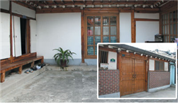
“When I prayed in tears, there was a time in winter that my cotton trousers became completely soaked from the tears. You can imagine how serious I was. To keep from falling asleep, many times I prayed with a knife in my hand.”

Because a National Cemetery is located in Heuksok-dong, the fields and mountains of True Father’s past are still preserved there. But sadly, Gi-bong Lee’s boarding house, where True Father stayed, was torn down in December 2008 due to redevelopment. At present this area, where we plan to make a new holy ground, is open for members to pray and offer devotion.
According to True Father’s second cousin, Seung-ryong Moon, the two of them shared a room at Gi-bong Lee’s boarding house, and in the room next to them lived a Christian missionary, Deok-pal Gwon, and True Father’s friend, Gu-bok Yu. Across from the boarding house there is a convenience store at 46-1 Heuksok 2-dong, which was the home of Gi-bong Lee’s younger sister, Gi-ha Lee, where True Father rented a room for one or two months.
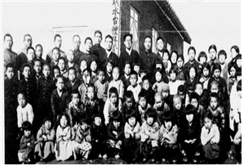
At that time, True Father went to the Jesus Church that Reverend Yong-do Lee had founded in Pyeongyang in June, 1933. The Myeong-su-dae church was the only branch of this church in South Korea. Rev. Yong-do Lee was responsible to play a pivotal role in preparing for the providence of the Advent of the Second Coming through the spiritual work of Christianity and, according to True Father, he was the figure chosen to attend True Parents.
True Father not only served as a Sunday school teacher, but was also actively involved with street witnessing and in fellowship with the members. He would give away his tuition money to the poor who “lay moaning in the ridges between rice paddies.” He would also go to the slums of Jungji Island and teach the children, telling them useful and interesting stories, and even cut their hair.
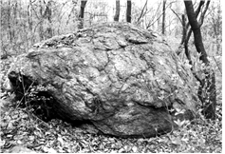
He gave money to the poor by saving his streetcar fare and walking instead. During vacations he would not return to his hometown, but would spend his time offering devotion out of concern for the future of his country. He wore shabby clothes and maintained a poor appearance, with a humble heart and downturned eyes, leading a life of sanctification. He never heated his room even during the worst cold of winter. Also, for more than seven years he fasted on his birthday and ate only two meals a day, as he experienced the sorrow of God’s heart.
True Father lived at Mrs. Gi-bong Lee’s house again after he returned in October, 1943, from studying in Japan. Knowing that independence would come soon, he settled down in Heuksok-dong and made plans to start the Unification Movement in politics and religion with Baek-moon Kim, who was chosen by God, of the Israel monastery. Unfortunately, True Father’s will could not be fulfilled due to the disbelief of the spiritual group. Moreover, the Japanese authorities discovered that True Father had led an independence movement. They arrested him and took him to the Gyeonggi-do Provincial Police Department, where he suffered severe torture between October 1944 and February 1945. In the end, unable to start the providence due to setbacks on the individual and family levels, True Father left for Pyeongyang, North Korea on June 2, 1946, holding back his tears.
However, True Father’s connection to Heuksok-dong continued. During the Korean War, after he escaped from Heungnam Prison and was on the way to Busan from Pyeongyang, when he reached Seoul he stopped by this place, on December 30, 1950. On April 17, 1964, True Father went to Seodal Mountain (also called Dalma Mountain) in Heuksok-dong, where he had often climbed and prayed during his school days at the Kyongsong Institute of Commerce and Industry, and proclaimed the Day of Substantial Restoration. Later, because the National Cemetery was expanded into the area where the proclamation took place, he chose a holy ground near the top of the mountain. On December 31, 1965, at 1 p.m. he blessed all four holy grounds in Seoul as one, out of 120 in the world.
True Parents visited again on May 7, 1987, and provided funds to have the Heuksok-dong church rebuilt. They explained that Heuksok-dong should become the base of tradition. Heuksok-dong is the purified holy ground where True Father lived for six years, and on January 5, 2003, it was the first place he came to after the four cheers of Ok Mansei for the establishment of Cheon-Il-Guk. He also said that Heuksok-dong should be the model for restoring God’s dominion. Also, True Parents once again expressed their love for Heuksok-dong by visiting on May 10, 2005.

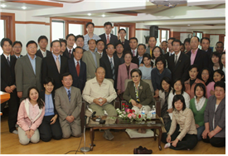

True Father said that Heuksok-dong (meaning black stone) should become Baeksok-dong (meaning white stone). “This valley of darkness, this place that I lived, should become a base of tradition that shines like bright sunlight to all people of the world.”

