FFWPU Mission Statement
Guide America back to God through the teachings and Marriage Blessing of True Parents.

Purpose of Tribal Messiahship
To inherit and expand the victorious foundation of True Parents, by loving, teaching and blessing those in our family’s sphere of influence.

Fulfillment of Tribal Messiahship
As with our own personal commitment to growth as a FFWPU member, Tribal Messiahship is also a process, starting with a proclamation to God, True Parents and our family. In this sense, every Blessed Central Family is already a Tribal Messiah. This is True Parent’s expectation of us and a part of their victorious foundation as alluded to in True Father’s final prayer. However, we need to own it. We need to start it within our own family.

Conditions of Victorious Tribal Messiahship
What is our goal, and what signifies a victoriously completed Tribal Messiahship foundation? Again, it is important to remember, that continued movement in the right direction is more valuable than just crossing a line. However, True Parents have established a standard, and it is healthy to start off with an ultimate goal in mind. Based off of True Parent’s words for the fulfillment of Tribal Messiahship, the goal is to give the Marriage Blessing to 430 families.
Because 430 is a large number of people, and it is not so easy to accomplish as one family, True Mother is encouraging us to accomplish this number by working together with two other families as a trinity. Working together in this way, we can find creative ways of working together, supporting each other and holding each other accountable.

The global standard for victory as heavenly tribal messiah prescribed by the FFWPUI HQ is outlined below. Other relevant categories such as qualification, appointment, tenure, powers, promotion, disqualification, awards and others standards are listed in the heavenly tribal messiah law of the Cheon Il Guk Constitution.

1. OVERVIEW OF GLOBAL STANDARD FOR VICTORY AS HEAVENLY TRIBAL MESSIAHS
I. Victory as heavenly tribal messiah refers to the person that while performing his duties as a Cheon Il Guk citizen has formed a spiritual tribe of at least 430 families across three generations.
II. It also refers to the person that maintains a life of faith and has completed the blessing of all 430 families of the spiritual tribe.

2. CATEGORIES AND DETAILS OF THE GLOBAL STANDARD
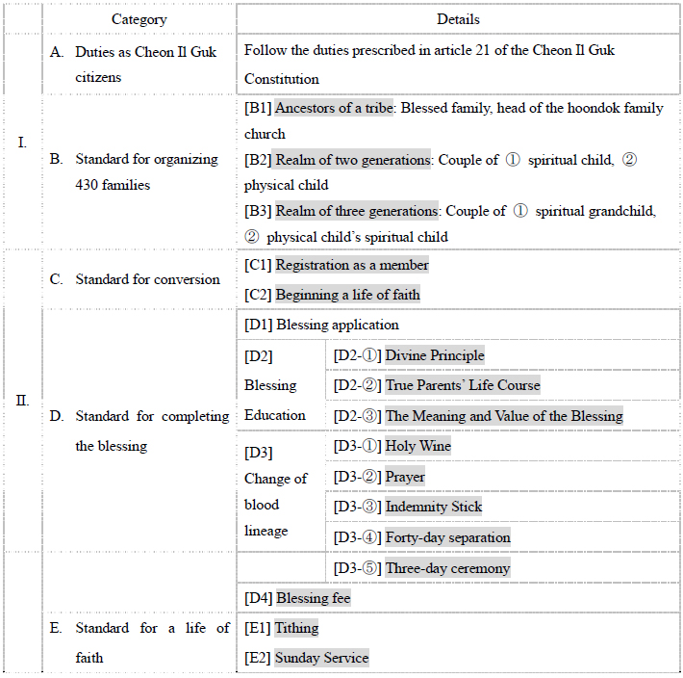

3. DESCRIPTION OF EACH CATEGORY OF THE GLOBAL STANDARD
A) Duties as Cheon Il Guk citizens: All citizens of Cheon Il Guk must follow and practice the duties outlined in article 21 of the Cheon Il Guk Constitution.
1. Citizens of Cheon Il Guk are required protect the pure lineage of Heaven.
2. Citizens of Cheon Il Guk must not violate one another’s hearts and rights as human beings.
3. Citizens of Cheon Il Guk must not misuse public funds.
4. Citizens of Cheon Il Guk should read, practice, disseminate and teach True Parents’ words.
5. Citizens of Cheon Il Guk should serve as hoondok family leaders and tribal messiahs for the substantial settlement and completion of Cheon Il Guk.
B) Standard for organizing 430 families: The spiritual tribe of 430 spiritual families must form in accordance with the three generations outlined below.
1. Ancestor of a tribe: Any blessed family that is head of the hoondok family church as prescribed in the Cheon Il Guk Constitution and Cheon Il Guk Regulations.
2. Realm of two generations: Organize the families of your spiritual children
① Spiritual families: Spiritual children and families witnessed to by those in the first generation.
② Families of one’s biological children: Blessed families formed by one’s biological children.
3. Realm of three generations: Organize among the families of your spiritual grandchildren
① Families of one’s spiritual grandchildren: Blessed families witnessed to by one’s spiritual children and spiritual families.
② Spiritual children of one’s biological children: Spiritual children and spiritual children of those in the first generation’s biological children.
C) Standard for conversion: A person is considered to have been converted if he or she fulfills and maintains the standards of a convert established by the national headquarters (Article 81, Cheon Il Guk Constitution) and by the regional presidents “appointed by True Parents” (Article 74, Cheon Il Guk Constitution).
1. Registration as a member: A person is considered a registered member when he or she completes and signs the registration form given by the regional headquarters or the national headquarters and resolves to begin a life of faith as a “Cheon Il Guk Citizen.” (Article 19, Cheon Il Guk Constitution).
2. Beginning a life of faith: The person must fulfill and maintain the standard of a member prescribed by the regional president or the national headquarters.
D) Standard for completing the blessing: A couple is considered to have completed the blessing when the standards described below are completed in accordance with the guidance of the regional president and/or national HQ.
1. Blessing application: Complete and sign the Blessing Application Form provided by the regional president or national headquarters.
2. Blessing Education: Blessing Education Candidates should complete the appropriate Blessing education based on their category and according to Blessing Regulations 1-A, B, C and 4-A, B, C.
① Divine Principle Education: The participant must understand God’s nature (Article 1, Cheon Il Guk Constitution) and the relationship between God and human beings (Article 2, Cheon Il Guk Constitution) through a basic Divine Principle education.
② True Parents’ Life Course: The participant must understand True Parents through an education on True Parents’ Life Courses.
③ The Meaning and Value of the Blessing: The participants must learn and understand the value of the change of bloodline. They must also resolve to become couples that are born anew and are worthy of the cleansing of the original sin through the blessing, which is administered by the Messiah, the True Parents of humankind (Article 26, Cheon Il Guk Constitution).
3. Change of bloodline
① Holy Wine: Each participant must understand the meaning and value of the holy wine before receiving it from the regional president or national headquarters and drinking it.
② Prayer: True Parents have sole authority for the Blessing of Marriage (Article 7, Cheon Il Guk Constitution). However, married couples may receive the prayer of a public official (Article 22, Cheon Il Guk Constitution) appointed by the regional president or national headquarters.
③ Indemnity Stick: The ceremony must take place under the guidance of a public official.
④ Forty-day separation: Every participant must complete a forty-day separation.
⑤ Three-day ceremony: Every participant must complete the Three-Day Ceremony prescribed by True Parents’ tradition.
4. Blessing fee: Each participant must offer the blessing fee determined by the international headquarters.
E) Standard for a life of faith: Each must lead a life of faith by fulfilling the two basic condition of attending Sunday service and tithing.
1. Tithing: Each person must tithe at least once every six months to one’s registered church or Hoondok Family Church (Article 20, Cheon Il Guk Constitution).
2. Sunday service: Each person must attend the Sunday service at one’s registered church or Hoondok Family Church at least once every six months. * The regularity of donation and worship service attendance can be determined at the discretion of each continent. However, the maximum period may not exceed six months under any circumstances.

4. MODIFICATIONS AND/OR CHANGES TO THE GLOBAL STANDARD OF VICTORY AS HEAVENLY TRIBAL MESSIAH
The above standard for victory as heavenly tribal messiah may be modified in accordance with the rules prescribed in the Cheon Il Guk Constitution and the Cheon Il Guk Regulations.

